CAPSTONE SUBMISSION FORM

Please complete the form below when you submit your capstone. It will help your instructor understand your code and give you all the points you deserve! Email it back to your instructor Thanks!

WHAT IS MY CAPSTONE ALL ABOUT
1) Can you provide a brief overview of your project and its theme?
My Project is all about registering teams and the players of the team in different types of soccer leagues happens around the world

2) How would a user (me) use your project? Can you provide a short "user manual" or instructions to the features you have included?

1 . A user can go and choose the league type and see all the teams and the member available in a page
2. They can add edit delete and search the teams
3. They can go to the member/player’s page and add , edit delete a player and go back to the teams page

3) Do I need a username to interact with your program? If so, what username and password can I use to get started? Are there users with special privileges? How does that work?
I have not implemented the user name portion

WHAT DO I NEED TO UNDERSTAND ABOUT THE SERVER

1) Can you explain how your data relates to "organizations", "groups" and "members"?
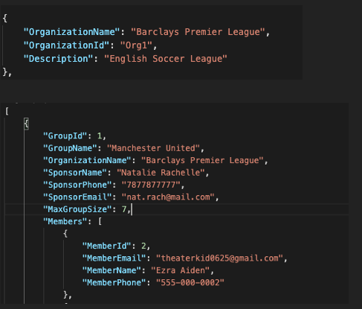

2) Did you clean up your data and reset your counters.json file?

No I did not

3) Did you make changes to server.js other than name mappings? If so, what were the changes? (include a list of any new API methods)

No I did not

GETTING ALL YOUR POINTS
1) Did you implement each of the following?
yes A "Home Page" that includes a description of your "theme" and an attractive list of the "organizations" in the system

yes The ability to search for and view a list of groups based on criteria that makes sense for your theme. Include a "view all groups" option

yes The ability to register a "group"

In my project, this means: add teams

yes The ability to add an "item" to the "group"

In my project, this means: Add players

yes The ability to view a particular "group's" details and the "items" in that "group"

In my project, this means: click on the teams row

yes The ability to edit an item's information (as appropriate)

the player form is editable

2) What techniques did you use to display error messages that users enter bad data in forms or when your Ajax requests return errors?
Alert box
3) Do you have:
yes Good HTML and CSS (readable, commented, no validation errors, etc.)

No Linted server.js and all of your site's script files

yes Readable, commented code with proper names, good use of functions, etc

yes Use of GitHub Repo with appropriate branches, commit history / comments, and an
informative README.md file

4) What innovative feature that we didn't discuss in class (new Bootstrap or Angular feature, etc.) did you incorporate? How did you learn about it? What made you decide to use it?
Prime Ng . In our project we use Prime NG . its an easy library to show the tabular data

5) Who are some of the people you collaborated with on this project and how did they help you or how did you help them?

All my class mates helped me a lot

6) Did you implement any of the following features to earn bonus points? Elaborate!
yes The ability to edit a "group's" details - for example, to change a sponsor's name and/or email

In my project, this means: If you click on the row the editable form will appear

yes The ability to delete a "group"

In my project, this means delete teams

yes The ability to delete an "item"

In my project, this means: delete Player

No The ability to register a user / logon to the site

No Wild card feature - If so, tell me more about it! What does it do? Why is it cool? What did you learn implementing it?

SUMMARY
1) What else do I need to know about this project?

2) Comments?
I learnt a lot in this class . Thanks you so much Kevin

